Interactive Egypt

Write up

By Rehaf Aljammaz, Beth Oliver, Abdul Jawad, Carinne Knight

# **Related work: Summaries\***

In the following section, we present related work by summarising a few articles and research papers handling historical artifact objects, visualization applications, methods commonly used and present their conclusions.

*\* text in this section is paraphrased, or quoted - authorship belongs to the original writers*

**3D Visualizations of cultural heritage artifacts, by Barsanti et la[1]***\**  Barsanti [1]et la's paper investigates the use of VR technologies with Egyptian artifacts. Their goal is to make the artifacts (funeral artifacts in museums ) more engaging and accessible. The authors proposed creating an immersive VR environment by combining the use of an oculus rift and a leap motion devices.   
 Barsanti's [1]study focuses on examining funerary artifact objects and understanding their translation of the Egyptian language through visualizations. The team's VR applications relied on the use of 3D models, VR devices ( Oculus ) and software applications.   
 Barsanti's [1]team used photogrammetry, by moving the cameras and using tripods to obtain the shape and textures of the selected artifacts. After generating the models, using multiple applications, the team used a leap motion device by attaching it on top of an oculus rift dk2 device. Combining the devices allowed the users to grab, rotate and move the 3D objects within the scenario, thus enhancing the experience. The team used Unity 5 to develop the visualizations and 3D studio max to refine the models.   
 Based on a test, the usability controls, and visualizations seemed successful in their purposes. However, displaying text was one of the issues the team faced in their low-resolution visualizations[1]( since a part of the project aimed a translating text this was important). They made the text more readable by adding in widgets that displayed the text in a larger font and contrasting its color with the background. Another issue reported was feelings of nausea after extended use. Still, this is common with VR applications.   
 Barzani concluded his paper by stating that combining low-cost devices ( ex: Oculus and leap motion) can be used to produce realistic VR applications that solve two main museum barriers. Economic, where museums usually can't afford large expenses and practical where such devices use less space, needed by the museum.

**a Framework for Low-Cost Multi-Platform VR and AR Site Experiences.**

Wallgrüna et la suggests a low-cost multi-platform method for creating virtual and augmented visualizations toward sites that are inaccessible due to costs or safety concerns. Their paper talks about two main approaches, the first utilize 360° Photographs & Videos and the second examines creating models using the "Structure-from-Motion" technique. The paper also suggests a technical framework for maintaining the applications, however, it is outside of my own understanding and the project’s scope.   
 The first technique is surprisingly simple; it involves capturing photos ( 360 photos or video) and placing it inside a Unity sphere object. The process creates a 2.5D experience for users, from a 2d dataset (images). On the upside, it is proven to be an easy and cost-effective way of creating scenes. However, the downside in following this approach is in its limited user interactivity( since there are no 3d models to interact with).

Their second suggestion is to construct models from images using photogrammetric techniques or what is known as "Structure-from-Motion(SFM)" techniques. SFM is usually used to build large geometries (ex: elevation of terrains) by obtaining 3d measures from 2D images; it can also be used to create smaller artifacts(specifically using Agisoft PhotoScan software).   
 The authors then examine and evaluate the methods on different projects. The authors referenced known problems and challenges within the XR field in their evaluation, (needs examining further) including:

1. Classical issues such as usability (referenced Davis)
2. Issues that come with the nature of XR application  
    such as the features and experience themselves, the spacial sense used and interactivity (what is known as presence, embodiment, and interactivity in referencing Slater, Sundar, and Kilteni's works)
3. How to direct the evaluation effectively as it differs based on the components used( ex: device HTC vs. cardboard, AR vs. VR).

The authors' work presents a practical approach to producing content for mixed reality applications that are both fast and inexpensive.

**MixAR Mobile Prototype: Visualizing Virtually Reconstructed Ancient Structures In Situ**

Unsatisfied with the lack of nuance in 2D analysis, scholars have worked to develop techniques that better replicate real-world vision processes. Most such quantitative studies, however, still fall short of incorporating the qualitative aspects of human perception. In the above mentioned research paper David Narciso and others discussed about the virtual reconstruction of ancient buildings to provide digital insight of how these historical places could have been in ancient times. These buildings are commonly found in the advance state of degradation Concerned with this challenge they aimed to provide the visualization of virtual buildings augmented upon real ruins. including its interiors and exteriors. In their MixAR system some modules support the achievement of this goal: a mobile unit responsible for providing and managing the MR experience to users; a high performance server to store, manage and deliver relevant data to the MR experience as well as to act as a remote processing unit; a network infrastructure to support the communication between the aforementioned mobile unit and server. Following figure shows the general architecture of the system:

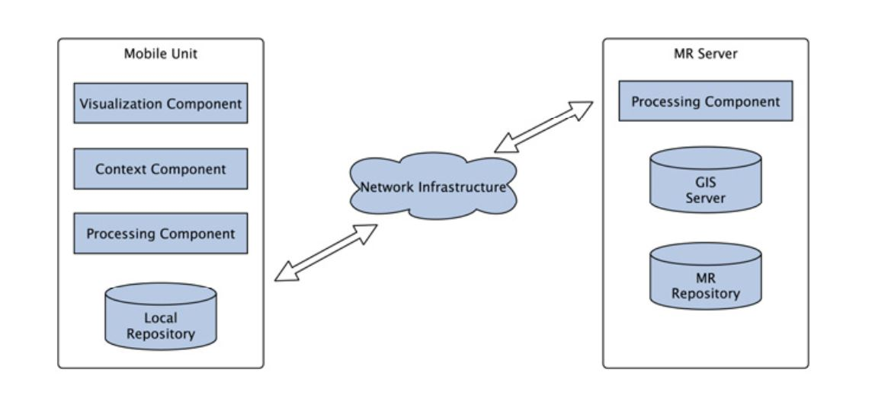

Their work is particularly interesting because they incorporated virtual models in AR/Augmented Virtuality (AV) systems to promote the scientific participation of the general public in culture, history or archaeology (considering the importance of digital heritage in modern society). The ability of such kind of environments in combining the real world with virtual information has the potential to provide a compelling and attractive user experience that, on the edge and regarding the current context, seeks the induction of the sensation of being travelling to the past. The inherent business model behind these kinds of systems usually targets museums, tourism and related fields.

**VIRTUAL RECONSTRUCTION OF LOST ARCHITECTURES: FROM THE TLS**

**SURVEY TO AR VISUALIZATION**

Quattrini and Pierdicca in the above research presented a virtual anastylosis, starting from historical sources and from 3D model based on TLS (Terrestrial Laser Scanner) survey. Their work presented a discussion about the use of 3D models and their simplification to cope with Mobile AR limitations. The work demonstrated the feasibility of a 3D reconstruction approach for complex architectural shapes starting from point clouds and its AR exploitation, allowing the superimposition with archaeological evidences. Due to hurdles in visualization of high-quality 3D models of virtual anastylosis in AR open source environment, the work also proposed a VR tool. This allowed an easy portability of level of details from the 3D model, although the perceiving is very different and not compliant with the main goals of their approach.

**Uncertainty: The Art of Speculation**

According to Dr. Sullivan, the most important data to present in the 3D Saqqara project is uncertainty. Therefore, constructing a model of uncertainty within data visualization has become our team’s main objective. In order to determine the proper direction to take with 3D Saqqara, we must first contextualize uncertainty as a paradigm within data visualization as well as the implications derived by the form of uncertainty in a broader epistemological argument.

First, how do we define uncertainty? Generally, uncertainty describes the absence of information for one reason or another. This can mostly be attributed to either imprecision or incompleteness. With imprecision, the existence of certain data features can be assumed but not in detail. For example in an archeological site, we can assume the layout of a structure existed due to its footprint, but we don’t know how tall the structure might have been. Also, incomplete data infers that some information is just completely unavailable and unknown, such as whether or not walls were adorned with decorative detail or windows. Acknowledging these missing pieces is the first step to designing speculative paradata, which will be discussed in more detail later in this essay.

Artists have historically tackled the problem of illustrating or visualizing uncertainty by using established techniques for creative speculative representations. For example, architectural blueprint drawings have established certain aesthetic rules which only contain important referential lines to designate spaces to be formed. However, one may need to be formally trained in how to read such visualizations in order for them to make sense and form context in the reader’s or viewer’s cognitive mind.

Various simple techniques can be utilized to infer differing level of assumptive paradata. Contour line weight and thickness traditionally used in illustrative pen or pencil drawings can determine varying levels of acknowledged uncertainty. Additionally color, texture, opacity/transparency, blur/fuzziness, and lighting/shading (chiaroscuro). We can begin to visual these models within the context of archaeology as attempts of preserving a pentimento of the past; of preserving traces of possible landscapes conjuxtaposted with what presently exists. 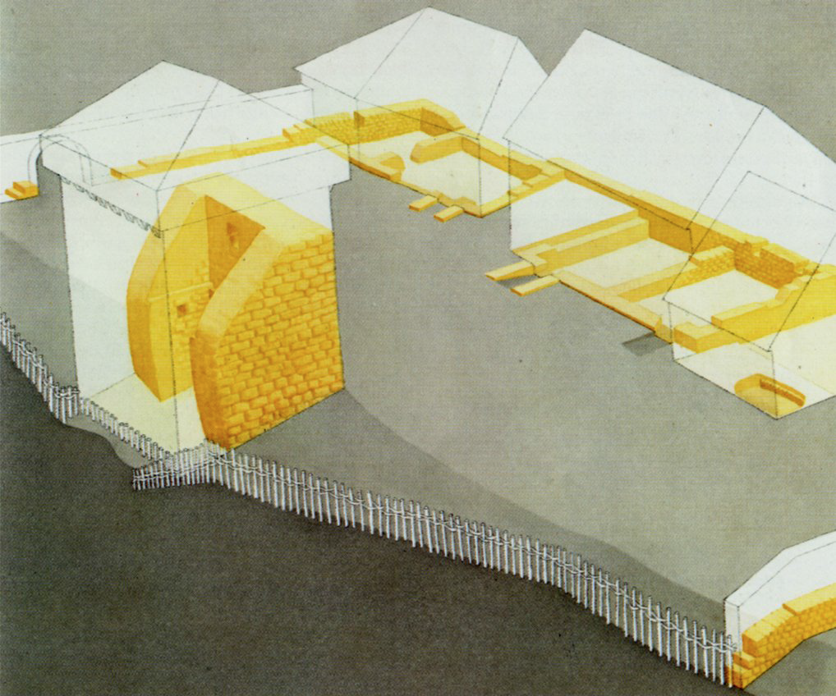

**From Strothotte, et al., a sample visualization of ancient architecture demonstrating variable levels of uncertainty. Some aspects are based on archaeological excavation and demonstrative fact, while others are more speculative based off of “learned guessing” or paradata.**

**Complications in Visualizing Uncertainty**  
 What concerns do we face in the representing data uncertainty in our model? “Within computer science, the area of *fuzzy systems* studies uncertainty in computer models.” (Strothotte) Below is a contingent list of issues for further research and exploration:

* Photorealistic images tend to leave their viewers with the impression that the objects depicted actually exist
* Visualization technology forces clear cut decisions
* Usually no support is made to confirm or check consistency to design decisions
* Softwares are lacking in appropriate methods & tools
* Cannot cure our total lack of knowledge archeological past
* Current forms often show our indecisiveness concerning an array of given possibilities
* Can only aspire a plausible antiquity, not the real one
* Inherent creation of cultural context, based on interpretative assumptions and choices

**Conceptual Implications** Further design and epistemological repercussions are to be explored within the context of criticism and philosophy. Various cultural and ethical ramifications are implicated especially in the field of archaeological data visualization.

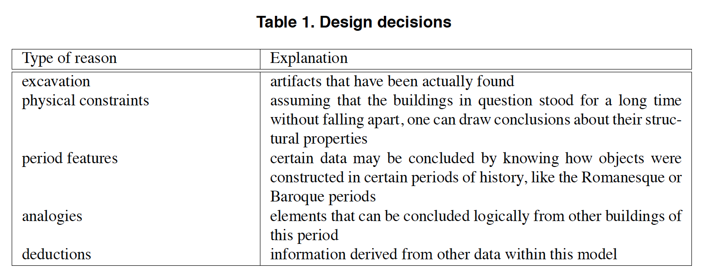

**Above, Strothotte lays out a table of how design decision should be made, stressing the importance of ‘analogous’ and ‘deduced’ decisions. Sullivan has expressed a similar framework when formulating her paradata.**

**Understanding Paradata and Uncertainty**

**Paradata**:

But what is paradata? The London Charter, an authority in the realm of computer-based visualization of cultural heritage, defines it as “evaluative, analytical, deductive, interpretative and creative decisions made in the course of computer-based visualization.” Lisa Snyder further breaks that down in VSim: Scholarly Annotations In Real Time 3D Environments to include

“the scholarly workflow employed, the technology used (hardware and software), and the interpretive process (e.g., providing explanations for the decisions made throughout the project), how the project was realized, and the relationship of the reconstruction to other research in the field.”

In simple terms, it is any information which would be necessary to recreate the project in question.

By recording and providing this information, a visualization can become “transparent, traceable, replicable, and correctable,” (Paradata and Transparency in Virtual Heritage) allowing other scholars to evaluate the work. This is important, as these visualizations, by their nature, cannot accurately depict things as they were but rather are always an image of what might have been, or as Willard McCarty says “computational models, however finely perfected, are better understood as temporary states in a process of coming to know rather than fixed structures of knowledge” (quoted in Paradata and Transparency in Virtual Heritage, but we should probably go and find the original context). They are always our best guess as to what things might have been, always open to change with new data or reinterpretation of existing theories.

By making our assumptions clear, by indicating which data points and current theories visualizations are based on, they become open to critique by other scholars. For this reason, the London Charter endorses the need for creators of visualizations to document their sources and their design decisions. However, they do not provide guidelines for how this documentation should be done. This is a problem not just for paradata, but the broader domain of annotations on 3D environments at large.

Ideally, annotations on paradata, source material, background knowledge, or scholarly commentary could be anchored in 3D space and would reflect temporal changes in effect on the virtual environment. Additionally, multiple kinds of file formats should be embeddable in the annotation, allowing for things as wide ranging as text, video, or sound.

Currently, however, there is no standard for in place annotation as described. More commonly, text descriptions are provided alongside the interactive 3D visualization, or conversely, static screen shots of the 3D visualization are provided within the textual description of the process. While this is “fine” this is not ideal, as it leaves a large gap between the textual description and the content of interest, relying “on the user to make meaningful connections” (VSim: Scholarly Annotations In Real Time 3D Environments).

**Proposed Project**

Our project aims at visualizing uncertainty (mentioned above in Uncertainty: The Art of Speculation) by using selected 3D models from a specified time period(TBD). One approach our team is considering is using the selected model and reconstructing their missing components and textures using tools such as Blender. We can later visualize parts of the model by referencing what they may look like based on similar models found in the same time period. One of our goals is to create shifting views of the model; the user can look at the models through a first-person view or glance at them from a bird's eye view. Creating multiple views provides the user with a more detailed visualization. Dr. Sullivan will oversee our project and provide the base models, assets, selected monuments and guidance as we develop the visualization.   
  
**Displaying data**  
 According to Dr. Sullivan it is essential to display both textual data and uncertainty data. Vital textual data includes:

* name of the dynasty
* Name of king’s reign
* Name of the building (ex: king teddy )

Uncertainty data has to have a quantitative measure in its display, measuring it as a scale from 1 - 5 or a defined range from A-C. Suggested methods for visualizing uncertainty models include:

* Using sea levels as a measure of height
* Hypothetical designs based on metadata. Manipulating the models.
* Manipulating the model's dimension levels ( scale).
* Manipulating the model’s color and transparency.

Based on the direction yet TBD for the project, the audience can be specialized (academics or Egyptologists) or publicly available. The primary goal of the project is to provide a proof of concept on visualizing a few models using Unity.

**Tools and engines:**

Our team will use the *Unity* game engine to develop a virtual environment for the project, where we will read data, manipulate models and create a VR application. We are currently deciding on a platform, one approach is to design it for the iPhone and Android systems as an application, and couple it with devices such as google’s cardboard. With this approach, we may reach a wider audience and have it easily accessible. Another consideration is the use of *Blender* in manipulating and reconstructing the 3D models from the base assets.

**Considerations**

From the related work mentioned earlier, It is apparent that there is a clear limitation of visibility in displaying texts in VR applications. Displaying clear text is a problem that is yet to be solved, one approach as Barsanti’s [1]team suggested is to manipulate the text and add widgets until we are satisfied with the readability of the result.   
 Devices such as the leap motion were shown in Barsanti’s[1] work to be a useful model for user interaction and manipulation ( in a similar setting ). Nevertheless, our project looks at larger scaled models(monuments), as opposed to small artifacts, where that level of manipulation is not necessarily needed.   
 We consider Wallgrüna’s[2] 360 approach a useful method for our project in creating aesthetically pleasing background settings; it is a relatively easy method to implement and adds a significant level of detail. Another approach comes to mind is Unity’s cube map method. The only downside with the cube map is a small cut off in the edges; it requires a complete transition in the image to give a good illusion. Otherwise, edges might be visible.

**Overall 3D Saqqara Project Goals: (Post-Interview with Dr. Sullivan)**

* **Create a model that shows uncertainty**
* **Utilize both metadata and paradata**
* **Focus on a single, specific time period**
* **Demonstrate potential viewpoints/perspectives**
* **Devise a better and more intuitive workflow**
* **Consider VR vs AR applications for content usage**

**References:**

[1] Gonizzi Barsanti, S., Caruso, G., Micoli, L. L., Covarrubias Rodriguez, M., & Guidi, G. (2015). 3D visualization of cultural heritage artefacts with virtual reality devices. In 25th International CIPA Symposium 2015 (Vol. 40, No. 5W7, pp. 165-172). Copernicus Gesellschaft mbH.

[2] Wallgrün, J. O., Huang, J., Zhao, J., Masrur, A., Oprean, D., & Klippel, A. (2017). a Framework for Low-Cost Multi-Platform VR and AR Site Experiences. The International Archives of Photogrammetry, Remote Sensing and Spatial Information Sciences, 42, 263.

[ ] Sideris, A. (2008, October). Re-contextualized Antiquity: Interpretative VR Visualization of Ancient Art and Architecture. In T. Mikropoulos, & N. Papachristos (Eds.), *Proceedings: International Symposium on “Information and Communication Technologies in Cultural Heritage”.* The University of Ioannina.

[ ] Strothotte, T., Masuch, M., & Isenberg, T. (1999, February). Visualizing Knowledge about Virtual Reconstructions of Ancient Architecture. In *Proceedings Computer Graphics International,* Los Alamitos, CA, 1999 (pp. 36–43). The Computer Graphics Society, IEEE Computer Society.